

Directions: Solve for *x*. Be sure to fully reduce your answers.

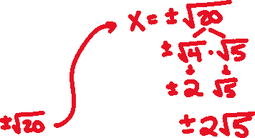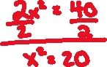

*x* =

$(x+3)^{2}=81$

 ____________________



*x* =

$(x-4)^{2}=36$

 ____________________







*x* =

$4x^{2}-20=40$

 ____________________







*x* = ____________________

